6.96: a) Along this path, y is constant, and the displacement is parallel to the force, so
b) Since the force has no y-component, no work is done moving in the y-direction.
c) Along this path, y varies with position along the path, given by 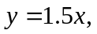 so 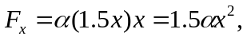 and
